**Database Assignment**

**EXERCISE 1**

**EXERCISE 2**

**

**

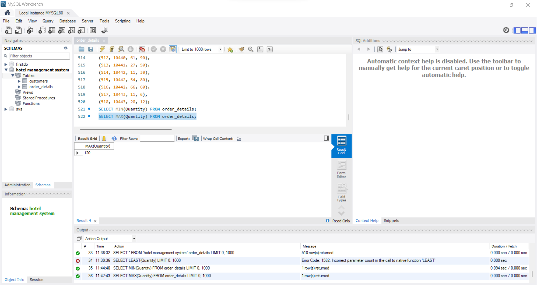

**5.**

**6.** 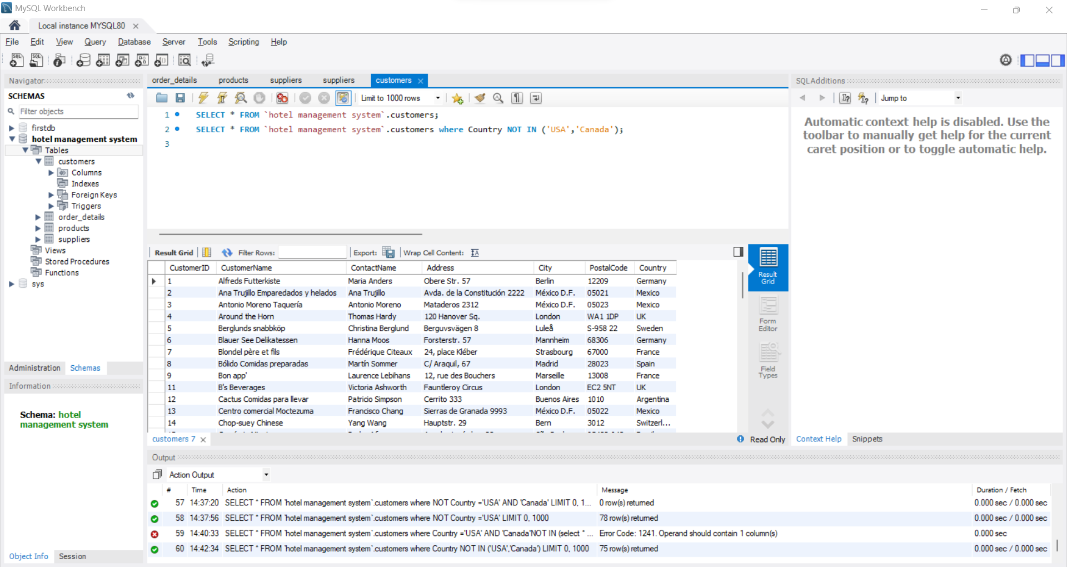

**7.**

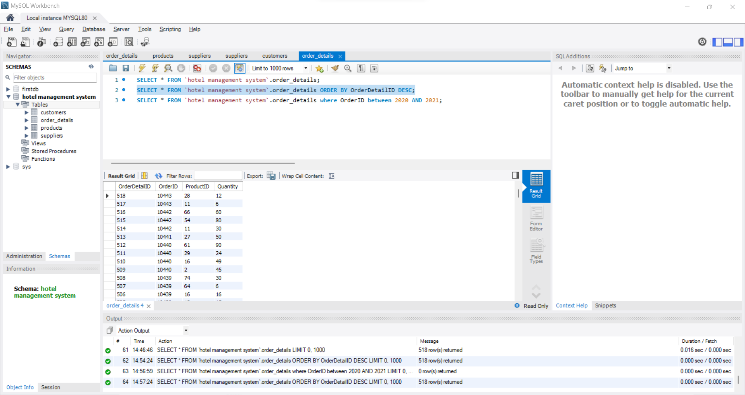

**9.**

**10.** 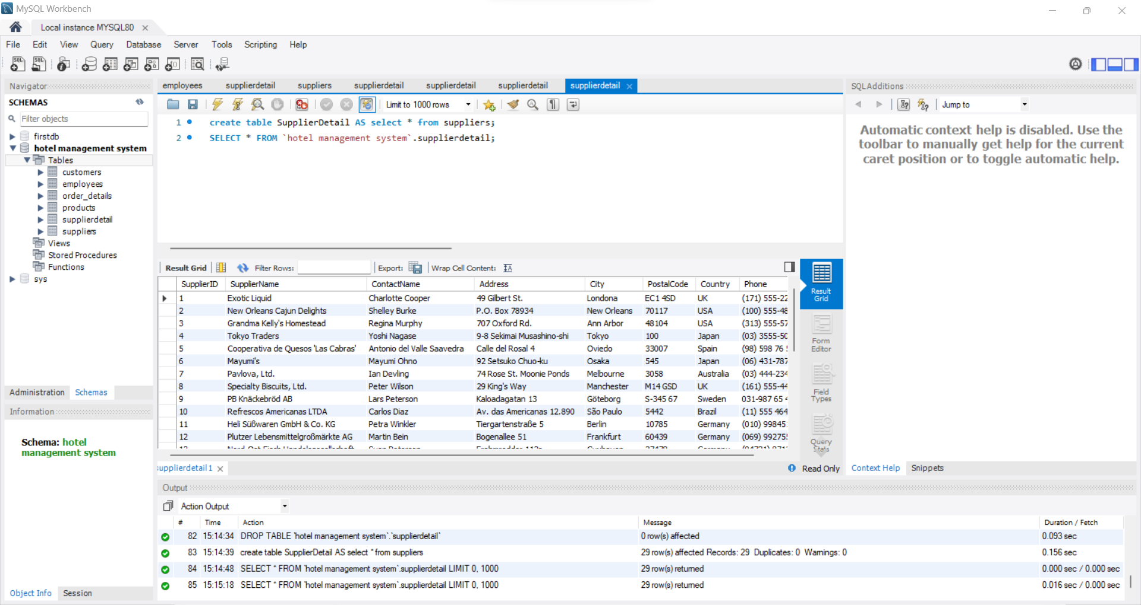

**11.**

